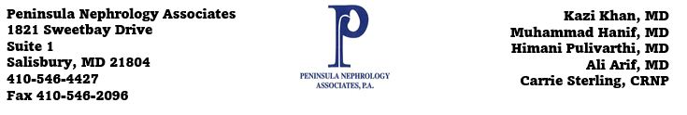
Patient Communication Consent to Contact Form
By providing your contact information below and completing this form, you agree to the following:
I hereby consent and authorize Peninsula Nephrology Associates, any associated physician or other caregiver, as well as any of their related entities, agents, or contractors, including but not limited to schedulers, billing services, debt collectors, and other contracted parties, to use automated telephone dialing systems, text messaging systems, and electronic mail to provide messages (including pre-recorded or synthetic messages, text messages and voicemail messages) to me about my account, payment due dates, missed payments, information for or related to medical goods and/or services provided, exchange information, health care coverage, care follow-up, and other healthcare information.
Patient Name: __________________________________ Date of Birth: ___________________________
Patient Address: ________________________________ City, State, Zip Code: _____________________
Home Phone Number: ___________________________ Mobile Phone Number: ___________________
May we leave voicemails or SMS Message on this line: YES or NO
Email address: ______
May we leave voicemails on this line: YES or NO
Patient Signature: ________________________________ Date Signed: ______________________
Patient Printed Name _____________________________

Contact Information
Name of person: _______________________________ Relationship: ________________________
Home Phone Number: __________________________ Mobile Phone Number:
May we leave voicemails or SMS Message on this line: YES or NO
Email address: ______
May we leave voicemails on this line: YES or NO

